1

Assignment 1.3 – Setup, Debugging, and Diagnostics

Eric McCool
Bellevue University - College of Science and Technology
Web340-339A Node.js
Professor Krasso
January 7, 2023

2
Part 1 – Installation

Display the help menu of the version manager you installed:
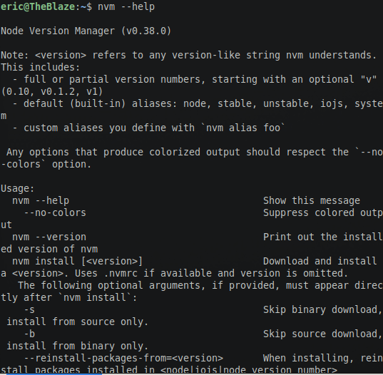

Display the installed version of Node.js:
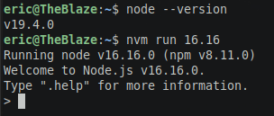

Display the installed npm version:
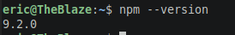

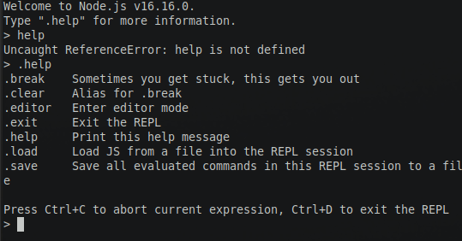
Display the Node help menu:

3
Part 2 – Debugging and Diagnostics

Open Chrome’s developer tools and inspect the file:
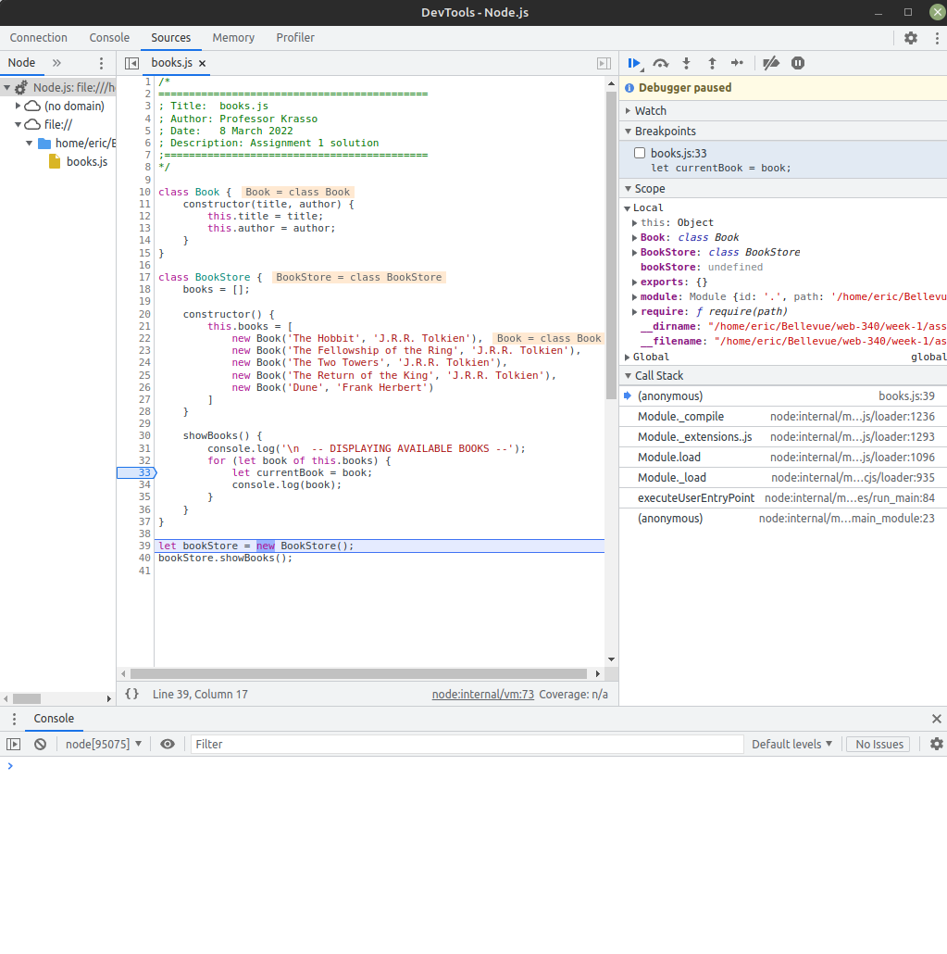

Add a break point to line 33. Take screenshots of each iteration with the updated values:

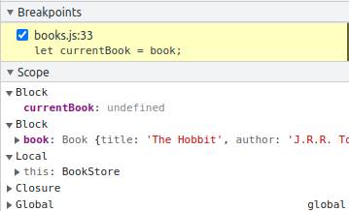

4
